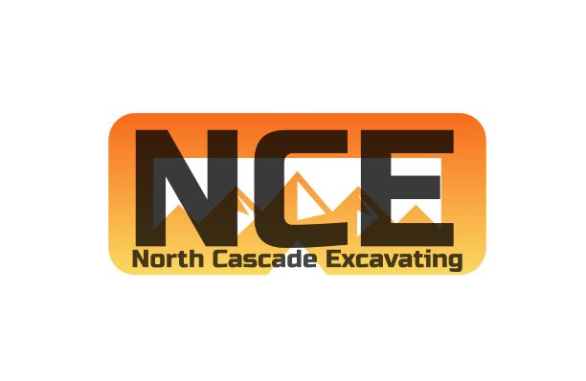

JOB OPPORTUNITY
FOR
NORTH CASCADE EXCAVATING
05/26/2023

LABORER
North Cascade Excavating, LLC is seeking laborers for civil earthworks and underground utilities projects. Projects range from private land developments, subdivisions, underground infrastructure, roadways, and environmental enhancements.
They should have experience in the construction industry, preferably in heavy civil earthwork or underground utilities. They are required to perform all laborer duties under the direction of the on-site project foreman.
Requirements;
- Past construction experience (any)
- Clean driving record and Drug free
- Exceptional work ethic
- Team player
- Quality/efficient communication, organization
- Positive attitude, punctual, kind, and honest
Desired experience in;
- Utility construction
- Earthworks
Benefits:
- 100% Medical, Dental, and Vision Premiums for Employees and Dependents
- 4% 401K Employer Match
- 7 Paid Holidays
- PTO Package
- 4 Day/10 Hr. Work Week (Pending Backlog)
Wages: $19 - $28 per hour (DOE)

