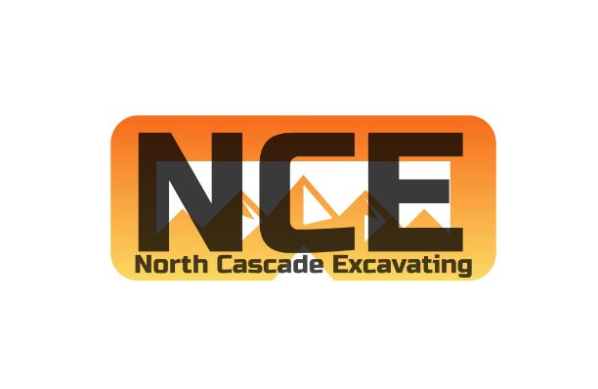

JOB OPPORTUNITY
FOR
NORTH CASCADE EXCAVATING
05/26/2023

OPERATOR/LABORER
North Cascade Excavating, LLC is seeking an experienced equipment operator/laborer for civil earthworks and underground utilities projects. Projects range from private land developments, subdivisions, underground infrastructure, roadways, and environmental enhancements.
They should have experience in all or most heavy civil earthworks equipment including excavators, loaders, dozers, rollers, and others. They are required to perform duties of a laborer while not operating equipment under the direction of the on-site foreman or superintendent.
Requirements;
- Utility installation experience (including pipe and rotating lasers)
- Plan and specification review and interpretation
- Knowledge of shoring and other safety equipment
- Training others on equipment operation and safety
- Clean driving record and Drug free
- Team player
- Quality/efficient communication, organization
- Positive attitude, punctual, kind, and honest
Desired experience in;
- GPS Machine Control
- Managing projects as an on-site Foreman
Benefits:
- 100% Medical, Dental, and Vision Premiums for Employees and Dependents
- 4% 401K Employer Match
- 7 Paid Holidays
- PTO Package
- 4 Day/10 Hr. Work Week (Pending Backlog)
Wages: $25 - $40 per hour (DOE)

