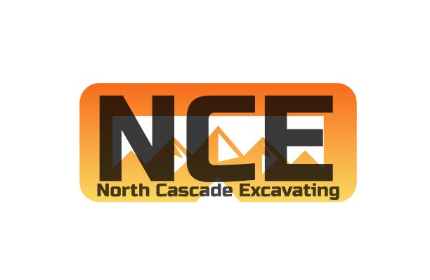

Job Opportunity Posting for Project Manager
PROJECT MANAGER
North Cascade Excavating is seeking a communicative, and detail oriented civil earthworks and underground utilities Project Manager for private and public civil earthworks projects. Projects will include, among others, private land developments, subdivisions, underground infrastructure, roadways, and environmental enhancements.
The Project Manager is responsible for managing projects from Award of the project to closeout and final payment. They will be responsible for fully understanding contract documents and relaying that information efficiently and clearly to the project team. They will work closely with the estimating department, field superintendent, construction team, clients, and all authorities having jurisdiction. It is anticipated the Project Manager will be responsible for managing between 3 and 5 projects depending on size at any given moment.
Additional responsibilities include, but are not limited to the following;
- Coordinating and attending preconstruction and progress meetings
- Preparing project submittals including;
  - Project schedules
  - Stormwater Pollution Prevention Plans (SWPPP)
  - Spill Pollution and Prevention Plans (SPCC)
  - Traffic control plans
  - Dewatering plans
  - Product cut sheets
- Preparing subcontracts and managing subcontractors
- Ordering and tracking materials
- Scheduling field crews and subcontractors
- Reviewing pay applications
- Preparing invoices
- Preparing purchase orders
- Tracking project budgets
- Coordinate with the field superintendent, project foreman and general manager regarding project status
- Preparing change orders
- Resource allocation
Skills;
- Clear communication
- Documentation/ organization
- Multi-tasking
- Interpersonal
Must be proficient in using;
- Microsoft Word/Excel
- BlueBeam or other PDF editing software
Desired experience in;
- MS Project or other scheduling software
- 2 years experience in managing Public Works projects
Benefits:
- 100% Medical, Dental, and Vision Premiums for Employees and Dependents
- 4% 401K Employer Match
- 7 Paid Holidays
- PTO Package
- Vehicle Stipend
- Annual Clothing Allowance
- 4 Day/10 Hr. Work Week (Pending Backlog)
Wages: DOE
$70,000 - $110,000
Email resumes, cover letters and references to info@nce.us

